HRMS — HR Payroll System
Attendance Control Center
User Manual
For HR Users — Step-by-Step Guide

1. What is the Attendance Control Center?
The Attendance Control Center is the starting point for every monthly payroll cycle. Before HR can enter any attendance data for the month, a new attendance file must be created using this tool.

Think of it as a register — every month you add one row, select the month and year, and click a button. The system automatically creates a fresh attendance sheet for that month, saves it in the correct folder, and records the file link in the register.

NOTE: You must generate the attendance file FIRST before doing anything else for the month. No attendance entry, leave balances, or payroll can happen without this step.

1.1 Who Uses This?
User | What They Do
HR User (pmo@butlerleather.com) | Opens the control center and clicks Generate Attendance File. This is the primary user.
Other authorised HR users | Can also click Generate Attendance File. The system routes their request securely in the background.

1.2 What Happens When You Generate a File?
- A new Google Sheet is created — named Attendance_January_2025 (example).
- The file is saved automatically in the Monthly Attendance folder in Google Drive.
- The file link is recorded in the ATTENDANCE_CONTROL register row.
- The completed row is automatically locked to prevent accidental changes.
- The new file is immediately ready for HR to begin attendance data entry.

2. Before You Start
Check the following before generating a new attendance file each month:

Checklist Item | Why It Matters
The previous month's attendance file is fully completed. | The system enforces strict month sequence. If January is the last entry, you can only generate February next — not March or any other month.
You know the correct Month and Year for this cycle. | Once a file is created the month and year cannot be changed. A wrong entry will require admin intervention.
You are opening the correct Attendance Control Center spreadsheet. | The script is locked to run only from the official control center file. Running from a copy will give an error.
You have a stable internet connection. | The file is created in Google Drive. A dropped connection mid-process could cause an incomplete creation.

NOTE: Always generate one month at a time. Do not add multiple months in advance — the system enforces this rule automatically.

Note: As more modules are added (Attendance entry, Leave, Payroll), additional pre-checks will be listed here for the relevant module steps.

3. Step-by-Step: Generating a Monthly Attendance File

Step 1: Open the Attendance Control Center spreadsheet.
Go to Google Drive and open the Attendance Control Center Google Sheet. You will see the ATTENDANCE_CONTROL sheet with a list of all previous months.
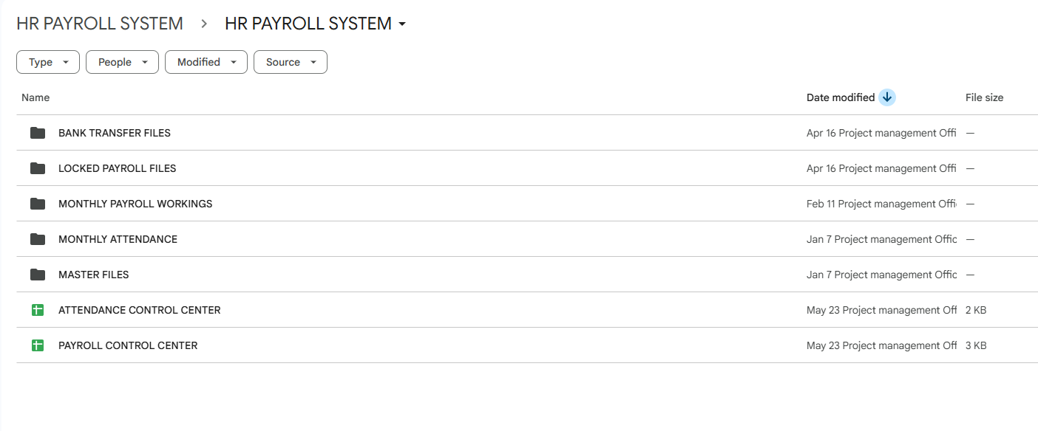

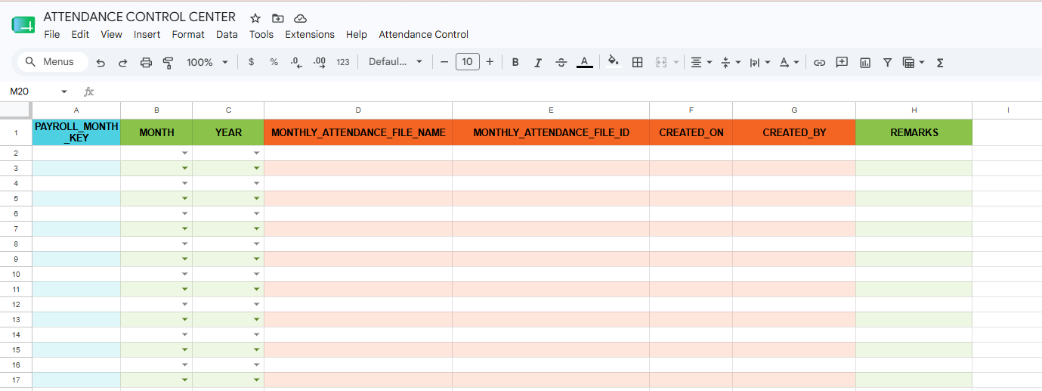

Step 2: Find the next empty row in the register.
Look at the register and find the first row where the MONTHLY_ATTENDANCE_FILE_NAME column is blank. This is where your new month entry goes.

NOTE: Never skip rows. If row 5 is the last filled row, your next entry must go in row 6. The system will block you if you jump to a lower row.

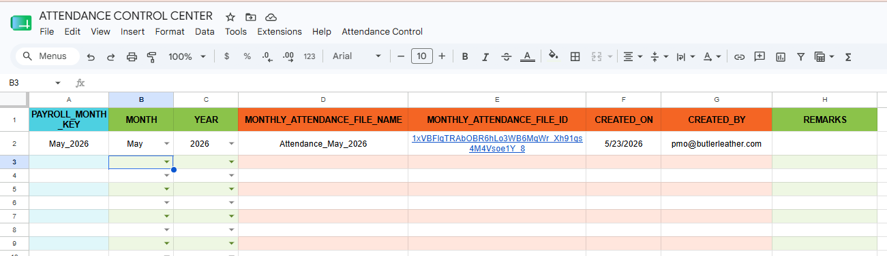
Step 3: Select the Month from the dropdown.
Click the MONTH cell in the empty row. A dropdown list will appear. Select the correct month for this cycle.

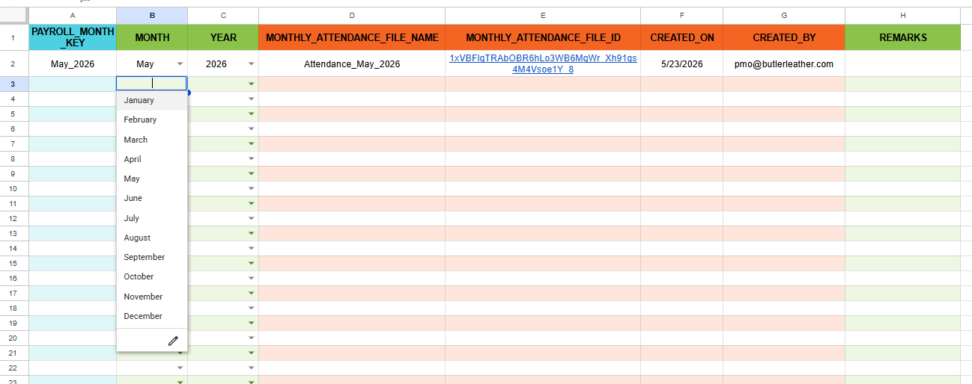

NOTE: The month you select must immediately follow the previous month in the register. If the last entry is January_2025, you must select February. If the last is December_2024, select January and use year 2025.
Step 4: Type the Year in the YEAR column.
Click the YEAR cell in the same row. Type the 4-digit year (e.g. 2025). Do not type a 2-digit year.

NOTE: Type "2025" not "25". The system will reject anything that is not a 4-digit number and show an error.

Step 5: Click "Attendance Control" menu → "Generate Attendance File".
Go to the menu bar at the top of the spreadsheet. Click "Attendance Control" and then click "Generate Attendance File".
5.a
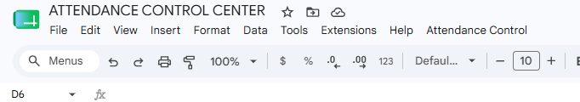
5.b
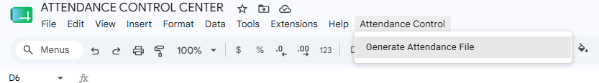

NOTE: If you do not see the "Attendance Control" menu, refresh the page (press F5 or Ctrl+R). The menu loads automatically when the spreadsheet opens.
Step 6: Wait for the process to complete (10 to 30 seconds).
After clicking, do not click anything else or close the sheet. The system is:
- Validating your entries.
- Checking for duplicates.
- Copying the attendance template from Google Drive.
- Saving the new file in the Monthly Attendance folder.
- Writing the file link, date, and your email into the register.
- Locking the completed row.

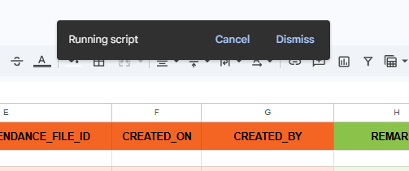

Step 7: Read the result popup message.
A popup alert will appear. Read it carefully:

SUCCESS: Attendance file created successfully. File Name: Attendance_February_2025 Row: 3 This means the file was created and is ready in Google Drive.

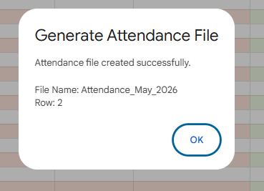

If you see an error message instead, refer to Section 4 of this manual for the exact error and how to fix it.

Step 8: Verify the register row is fully filled.
Column | What You Should See After Success
PAYROLL_MONTH_KEY | February_2025 (auto-filled)
MONTH | February (you entered)
YEAR | 2025 (you entered)
MONTHLY_ATTENDANCE_FILE_NAME | Attendance_February_2025 (auto-filled)
MONTHLY_ATTENDANCE_FILE_ID | Clickable hyperlink to the new file (auto-filled)
CREATED_ON | Today's date and time (auto-filled)
CREATED_BY | Your email address (auto-filled)

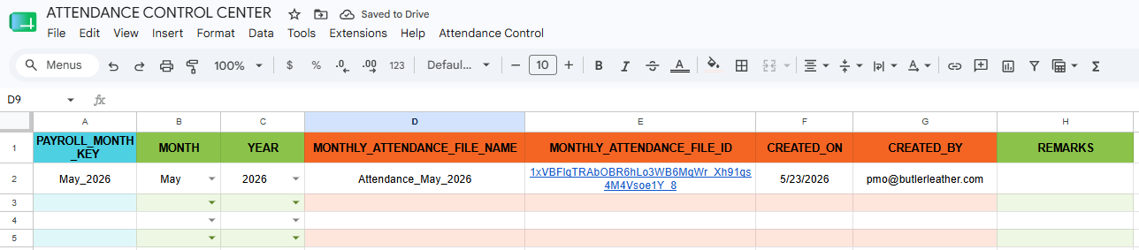

Step 9: Open the new attendance file and share with HR team.
Click the hyperlink in the MONTHLY_ATTENDANCE_FILE_ID column. The new attendance file will open in a new browser tab. Share this link with the HR team members who will enter attendance data for the month.
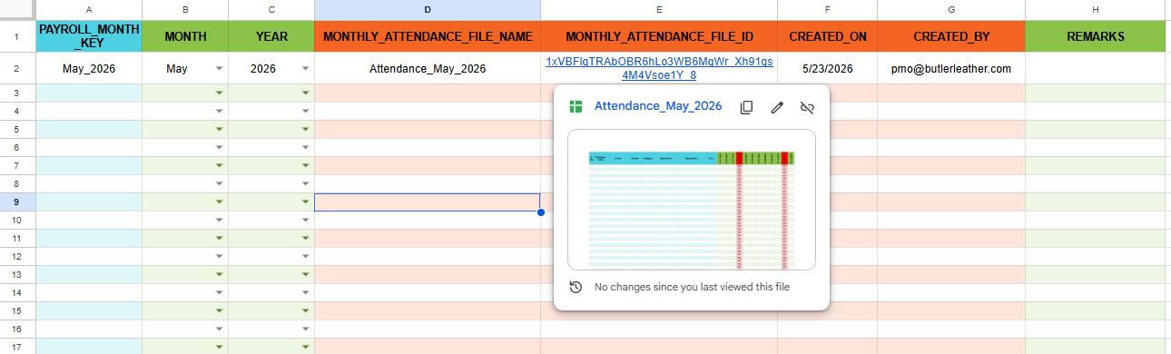

4. Monthly Workflow Summary
Every month, follow this sequence in order before starting attendance data entry:

Step | Action
1 | Open the Attendance Control Center spreadsheet.
2 | Go to the next empty row in the ATTENDANCE_CONTROL sheet.
3 | Select the correct MONTH from the dropdown.
4 | Type the correct YEAR (4 digits).
5 | Click Attendance Control menu → Generate Attendance File.
6 | Wait 10–30 seconds for the process to complete.
7 | Read the success popup. Click OK.
8 | Verify the row is fully filled (file name, link, date, email).
9 | Click the FILE_ID hyperlink to open the new attendance file.
10 | Share the attendance file link with the HR team for data entry.

TIP: Bookmark this manual. Refer to Section 5 (Error Messages) whenever you see an error popup you do not recognise.

HRMS — Attendance Control Center — User Manual | For HR Users

5. Error Messages — What They Mean & What To Do
If something goes wrong, a popup will show an error message. Find the exact message below to understand why it happened and what to do next.

Error Message (Example) | Why It Happened | What To Do
No pending row found. Please enter MONTH and YEAR in a blank row first. | You clicked Generate without filling MONTH and YEAR in any row first. | Go to the next empty row in ATTENDANCE_CONTROL. Select Month from dropdown and type Year. Then click Generate again.
Month is blank in row 3. Please select Month in that row first. | The MONTH cell is empty in the row the system found ready for entry. | Click the MONTH cell in row 3 and select the correct month from the dropdown.
Year is blank in row 3. Please select Year in that row first. | The YEAR cell is empty in the pending row. | Click the YEAR cell in row 3 and type the 4-digit year (e.g. 2025).
Year in row 3 must be a 4-digit value. | You typed an invalid year such as "25" instead of "2025". | Click the YEAR cell in row 3. Clear it and type the full 4-digit year (e.g. 2025).
Row 3 must be completed before using lower rows. Data is already present in row 5. | You entered Month/Year in row 5 before completing row 3. Rows must be filled in order. | Clear the entries from row 5. Complete row 3 first by entering MONTH, YEAR and clicking Generate. Then proceed to the next row.
Month continuity check failed. Expected: February_2025. Found: March_2025. | You entered March but the system expected February (because January_2025 was the last completed entry). | Correct the MONTH in the pending row to February. Months must follow in strict order — no skipping allowed.
Attendance month "January_2025" already exists in ATTENDANCE_CONTROL row 2. | A file for January_2025 was already generated previously. It is already in the register. | No action needed. The file already exists. Click the hyperlink in row 2 to open it.
A row already exists for "Attendance_January_2025" in ATTENDANCE_CONTROL row 2. | The same file name already appears in another row of the register. | Check row 2 — the file link is already there. Use that link to open the file.
An attendance file named "Attendance_January_2025" already exists in the Monthly Attendance folder. | A file with this name exists in Google Drive but was not created through this control center (possibly created manually). | Contact your system administrator. The stale file in Drive may need to be deleted before the script can create a fresh one.
Row 3 already has an attendance file reference. Duplicate creation is blocked. | Row 3 already has a file name and file ID filled. The script will not overwrite it. | No action needed. Row 3 is already complete. Use the existing hyperlink in that row.
Another attendance file generation is already running. Please wait a moment and try again. | Someone else clicked Generate at the same time, or a previous run did not finish cleanly. | Wait 30 seconds and click Generate Attendance File again.
This script must run from "Attendance Control Center" only. Current file: "Copy of Attendance Control Center" | You opened a copied version of the control center and ran the script from there. | Close this copied file. Open the original Attendance Control Center spreadsheet and run the script from there.
Web App URL is not configured. Please deploy the Web App and paste the URL in ACC_WEBAPP_URL. | The script has not been set up with a Web App URL yet. | Contact your system administrator. This is a one-time setup step that needs to be completed.

6. Do's and Don'ts

Do's ✅
- Always generate one month at a time in the correct sequence.
- Always select Month from the dropdown — do not type it manually.
- Always type the full 4-digit year (e.g. 2025, not 25).
- Always wait for the success message before closing the sheet.
- Always use the hyperlink in the register to open the attendance file.
- Always check the previous month is completed before starting a new entry.

Don'ts ❌
- Do not manually edit PAYROLL_MONTH_KEY, FILE_NAME, FILE_ID, CREATED_ON, or CREATED_BY columns — these are auto-filled by the script.
- Do not run this script from a copied version of the control center.
- Do not generate a file for a month that has already been generated.
- Do not skip months — the system enforces strict sequential order.
- Do not close the spreadsheet while the generation is running.
- Do not delete or rename the generated attendance files in Google Drive.

